Grade 7 Accelerated · Unit 3 · Lesson 2  Quotient Laws of Exponents  Independent Set 3.02 | Name______________________  Date______________________  Period____________________

Six questions, on your own, in silence. Show the step that does the work.
1. Write as one power. 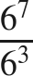

2. Find the value. 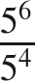

3. Find the value. 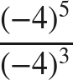

4. Rewrite so the exponent is on the numerator and on the denominator. 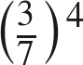

5. Find the value. 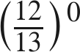

6. Find the value of . 